Boline Station Exercise
Boline Station suffered a loss of lines beyond that which was expected, and there were problems in the recovery as well. The task for the group is to determine the causes behind each problem, using the tools and knowledge expected of a system operator, as well as Cause Analysis Tools developed in the NERC Cause Analysis class in which you participated.

Initial conditions and electrical line-up are as shown:
- Moderate loads, stormy weather expected, moderate temperatures, Saturday afternoon, rumbles of thunder in the distance (isolated thunderstorms)
- Transmission station operations (no generation): 345 / 138 kV

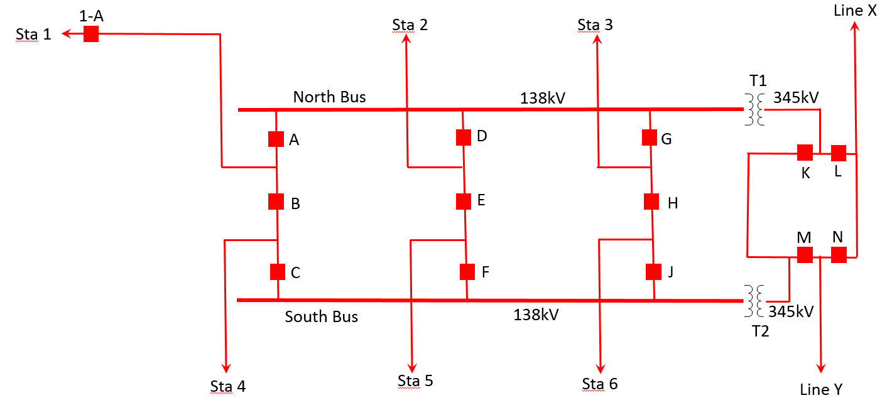
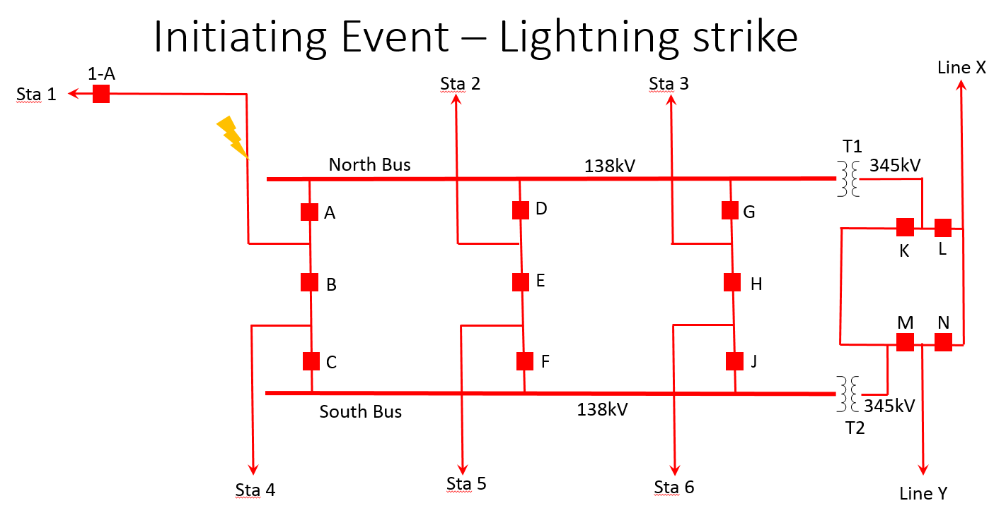

Let’s examine your Mental Model – what should happen?

Run “Lightning Strike Simulation.ppt” in Slide show mode.

How well did we get it?

What actually happened (after the dust settled)?
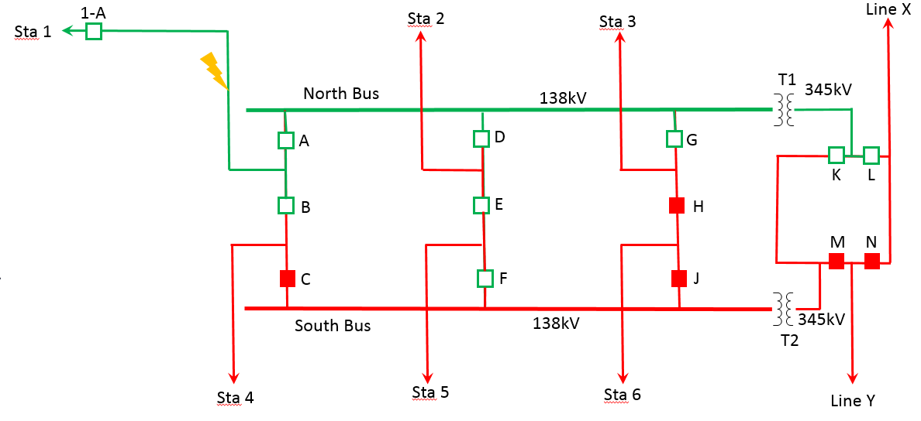

What happened??? How do you recover???

Switching Order to recover, followed by Task Analysis.

Once recovery is complete and analyzed, how did the event happen?

Change Analysis Form
Factors | Present Situation (Post Incident)? | Prior, Comparable (Planned Conditions)? | Differences? | Adverse Effects
What  Object(s)  Energy  Defects  Protective Devices | - North Bus de-energized  - Breakers A,B, D, D, F, G K, L open  - 3 lines tripped or open-ended | - Only Breakers A, B trip from lightning strike fault, with automatic reclosure | Fault isolation went beyond initial line isolation |  | Loss of North Bus; loss of transmission lines;
Where
On the Object
In the Process
Place
When  In time  In the Process | After lightning strike on Line to Sta 1 | After lightning strike
Who
Operator
Fellow Worker
Supervisor
Others
Task
Goal
Procedure
Quality
Working Conditions
Environment
Overtime
Schedule
Delays
Trigger Event | Lightning strike, followed by BF Lockout
Managerial Controls
Control Chain
Hazard Analysis
Monitoring
Risk Review

Barrier Analysis
Methodology

  - Identify and list the consequences.

  - Identify and list the failed barriers in place for each consequence.

  - Determine why (causes) the barriers failed (e.g., procedure not followed correctly)

  - Verify the results.

  - Develop corrective actions for each of the causes.

Barrier Analysis Worksheet*
Consequence | Barrier | Why Failed | Results | Corrective Actions
Line with fault connected to grid | Fault Detection system | None
Breaker failing to trip when fault exists | Breaker Failure Relay | Breaker did not fail to open but was identified with a failed breaker condition | Faulted conditions extends to other sections of grid | Isolate breaker
Breaker reclosing onto fault | Breaker Failure lockout | Received indication that Breaker(s) failed to open
Switching wrong breaker | - Effective communications;  - Switching order |  | Wrong breaker opened
Not understanding the expectations for both you AND your neighbors | Reliability Standards | None identified when CSA performed
Inconsistent work practices | Internal work procedures | Formal Processes not established  Organizational Drift | - No review of Engineering Design  - Expectation of a peer check or review that never occurred | - Formalize processes  - Stronger internal controls

Boline Station Scenario
During a normal day of operation, but with expectations of potential stormy weather in the area, a lightning strike occurred on the 138kV line to Station 1. The strike caused a fault on the line, with the system acting to isolate the faulted line. No maintenance activities or any other abnormal activities were taking place at the time of the event.

//////////////////////////////////////////////////////////////////////////////////////////////////////////////
The following is a summary of the detailed interviews and assessments made by your team with the personnel involved in the event.

From: Fred Merlo
Sent: Friday, August 26, 2011 1:27 PM
To: outage management
CC: Ben Done; Francis S. Key; Ahab Pequod; Hailey Jefferson; Jack Bower

Subject: System Protection Engineers
Changes to new System Protection Review Process.
I have been informed that we are now relooking all of the maintenance work done over the last two quarters of this year. It seems that we have had a single point of failure for all final wiring diagrams and we have let the time pressure for completion affect the accuracy of our work and most important, our quality control.

There was a very strong recommendation by Acme Vendor on alternate strategies and we didn’t listen. I thought for sure that it was made in their best interest to make more money, but we weren’t taking the time to listen. I think this is the best way to do it and I am sure that everyone agrees. However, that is what got us here in the first place and I am going to solicit feedback from everyone in the process to make sure we don’t drift this far away from our policies again. We are the ones that have to manage the outages so our plan should drive the decision. We are just going to have to formalize what I thought everyone knew. This is as much my fault as anyone else’s. We just can’t expect everyone to know policies that aren’t written down and taught.

New outage schedules will be issued, and we will need to communicate this to the relay testing group and all else who need to know. I look forward to getting our stellar group back up on top and eliminating all of these errors.

Fred

Fred Merlo
Manager

Utopia Electric Co.
3353 Peachtree Road NE
Suite 600 - North Tower
Somewhere, GA 30326
Office: 404.446.5678
Cell: 404.387.1234

From: Long N. Tooth
Sent: Thursday, August, 25th 2014 2:18 PM
To: Protection Engineers; Ben Done; Francis S. Key; Ahab Pequod; Hailey Jefferson; Jack Bower
Subject: RE: Jumper left in cabinet
Attachment: Boline1line.doc

Fred,

As discussed on phone, the contractor wired the cabinet exactly like the prints showed. That timer was bypassed by design. The last time we questioned the prints we got a 30 minute lecture and we started getting tired of asking. I still don’t understand how this made it through the quality controls that you described over the phone yesterday.

We are standing by to rewire and get this line back in service.

Regards,

Long

-----Original Message-----

From: Fred Merlo [mailto:fred.merlo@utopiaelectric. com]
Sent: Wednesday, August 24, 2011 1:27 PM
To: Protection Engineers; Ben Done; Francis S. Key; Ahab Pequod; Hailey Jefferson; Jack Bower
Subject: Jumper left in cabinet

Please review the wiring diagrams used for the new construction in Boline substation during the recent upgrades. One of the contractors left a jumper in the rack and caused a trip. I know our team didn’t do it but check anyway. I keep telling them that we check all of our work. I can remember just last month sending an email to the whole protection group to make sure that we follow all of our processes. I know that half of the team is new, but we have some solid processes that everyone knows.

Thanks all!

Fred

The information in this email is confidential and may be legally privileged against disclosure other than to the intended recipient. It is intended solely for the addressee. Access to this email by anyone else is unauthorized. If you are not the intended recipient, any disclosure, copying, distribution or any action taken or omitted to be taken in reliance on it, is prohibited and may be unlawful. Please immediately delete this message and inform the sender of this error.

Warning: This email comes from an external sender. Be cautious when opening URLs or attachments from external senders.

